HW5

1. Calculate:
   1. The resonant length and self-impedance of a narrow slot (w/λ=0.016 and negligible thickness) at the first and second resonance. For the second resonance, you need to approximate the input impedance of a 1-λ-long dipole.

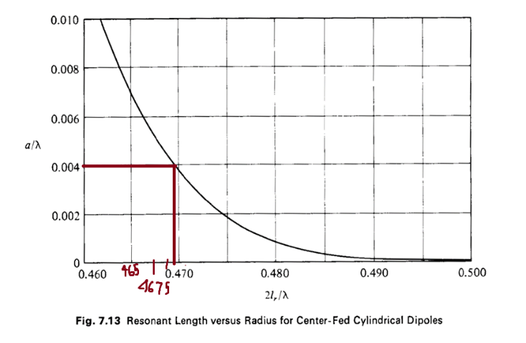

Optimal Length for first resonance.

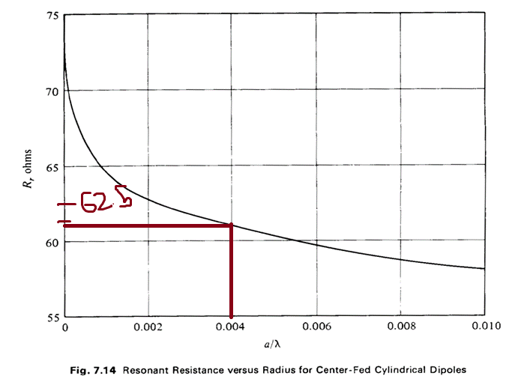

Input Impedance for first resonance.

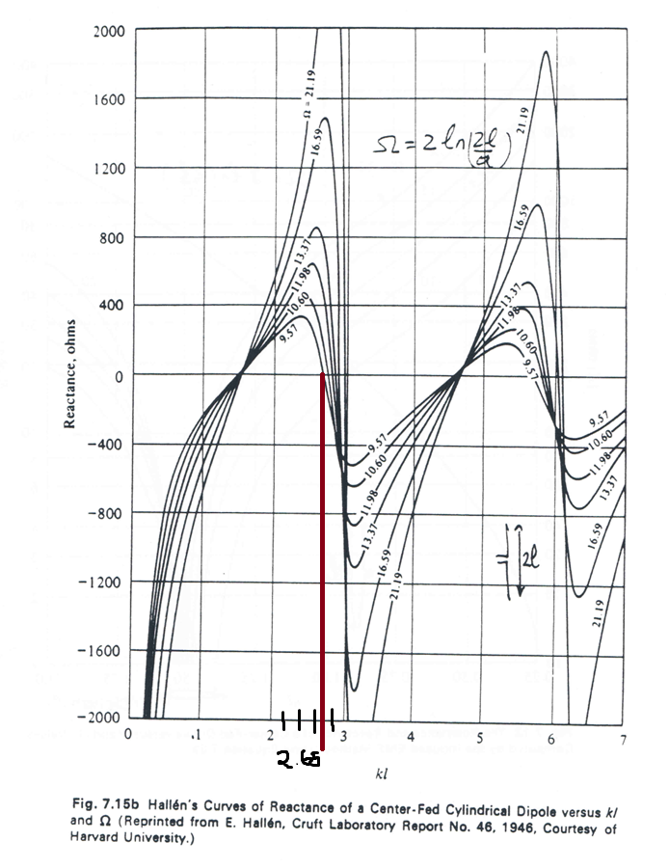

Optimal Length for Second Resonance.

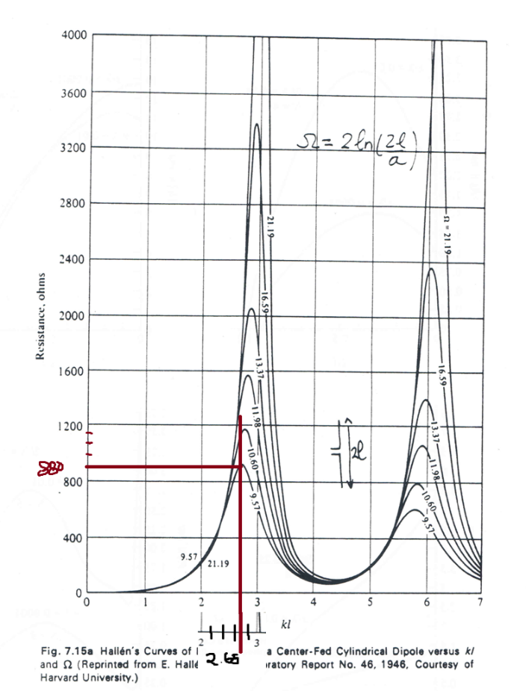

Input Impedance for Second Resonance.

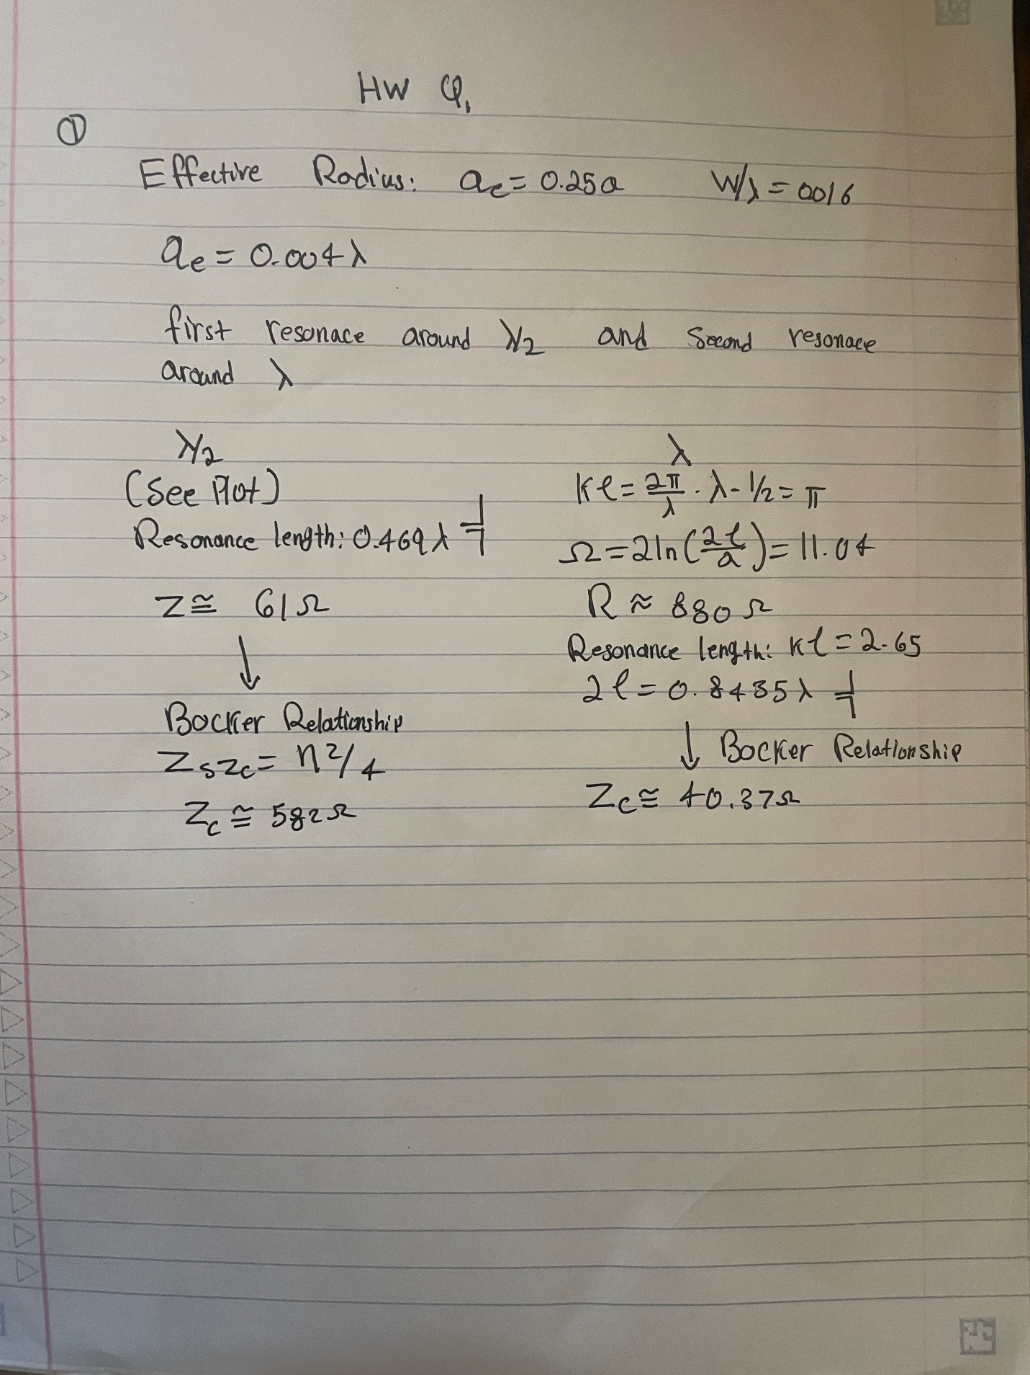

* 1. The mutual impedance and new input impedance of the slot antenna at first resonance when placed λ/4 away from a ground plane. Do it using (1) image theory and slot antenna and (2) the complete dual and replacing all metals with air and all airs with metal. Prove that they are the same.

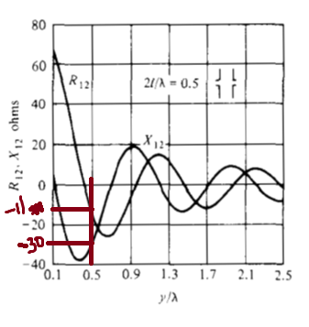

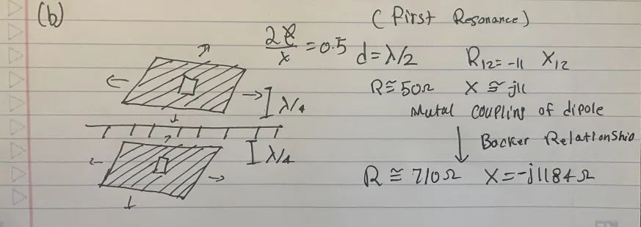

1. Consider the patch antenna with thickness t<<λ, dielectric constant εr, and dimension (a, b). for (m, n)=(0,1), and εr=2.2 and 10.2 (two cases),
   1. Calculate the dimensions of the antenna to resonate at 1.57 GHz. Choose b=1.4a.
   2. Draw the magnetic current and electric field distribution on the faces x=0, x=a, y=0, y=b. For one case only.

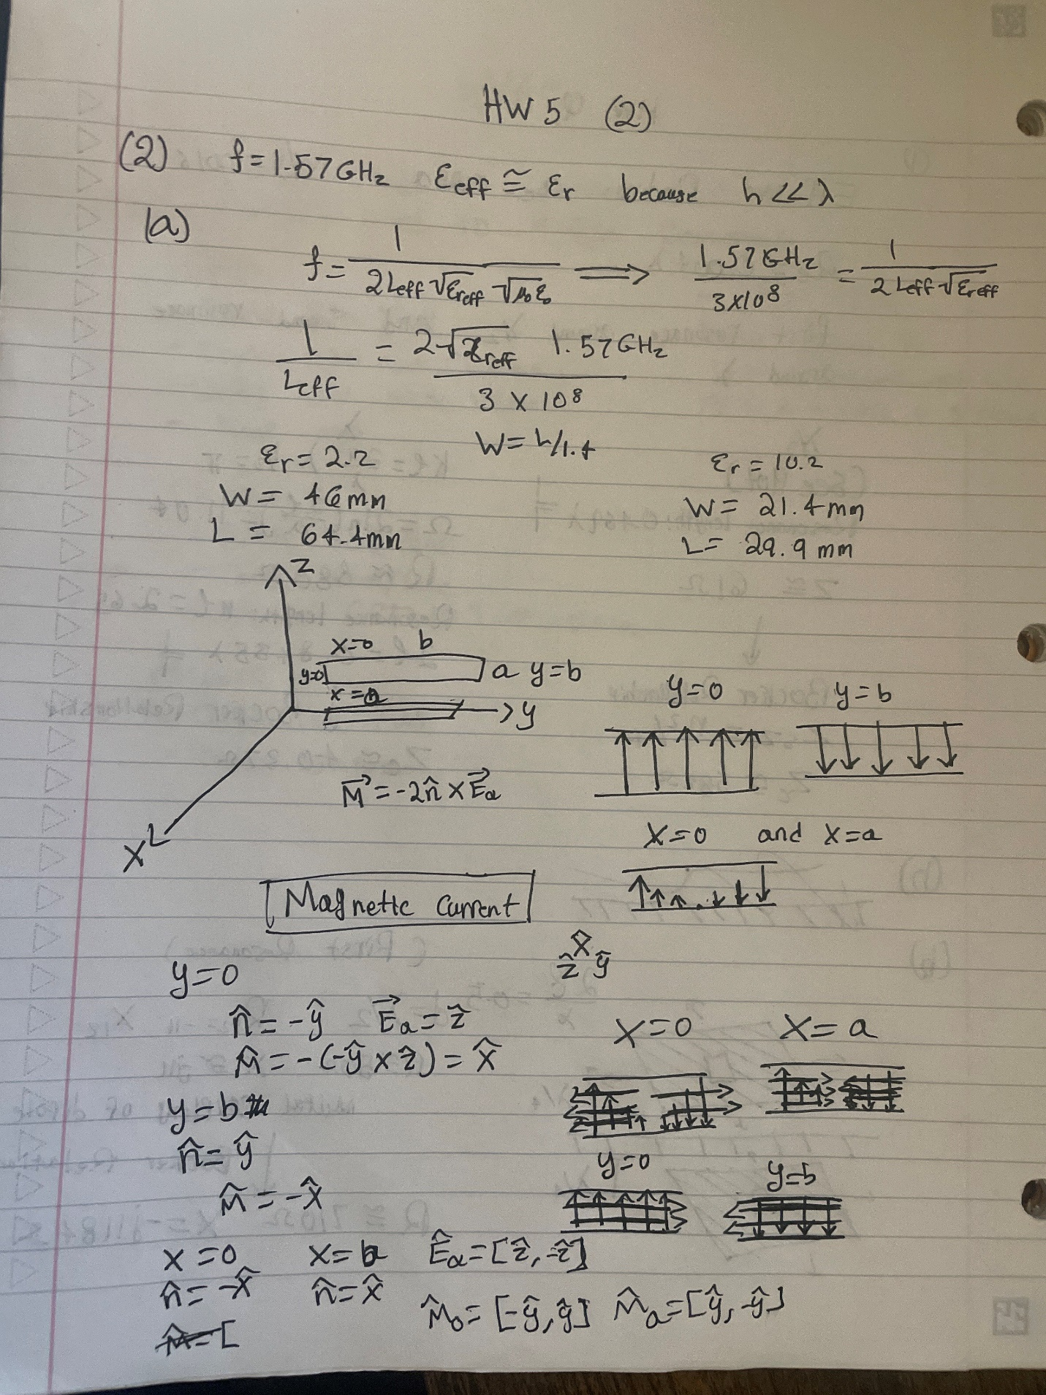

* 1. Calculate and plot the E, H, and phi=52 degree patterns by considering the magnetic currents on the faces y=0, y=b (linear polar). Calculate the directivity. Why the directivity of the antenna with εr=2.2 is higher? Which antenna is better for GPS application?

I would choose a higher directivity for GPS application because it has wide enough beamwidth to cover the sky. We need a higher directivity to use less power to communicate with satellites. However, the directivity cannot be too high since we cannot assume that the antenna will be pointed at the GPS satellites very accurately. Also, we must communicate with at least 4 GPS satellites.

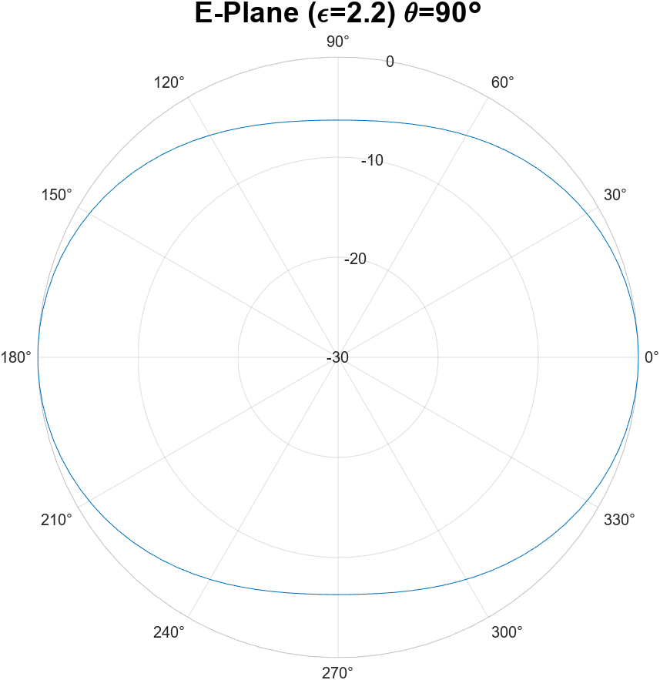

Figure 1

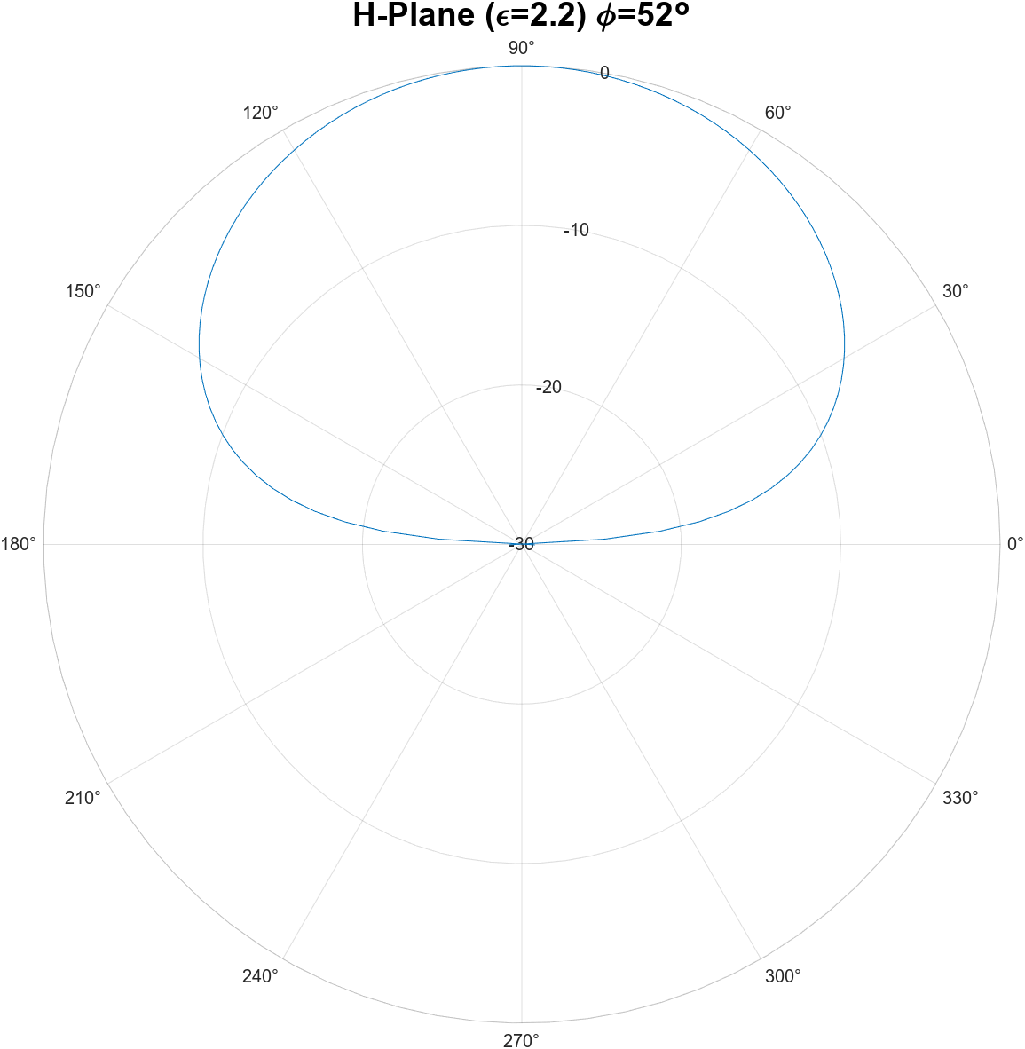

1.92 dBi

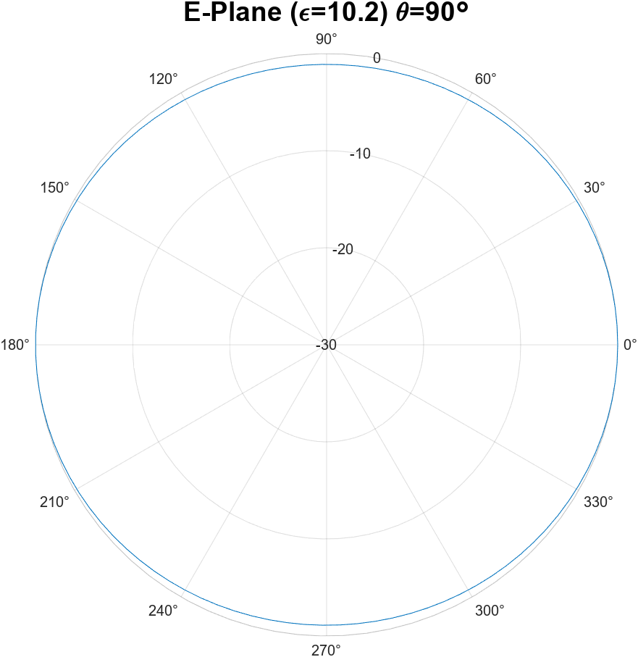

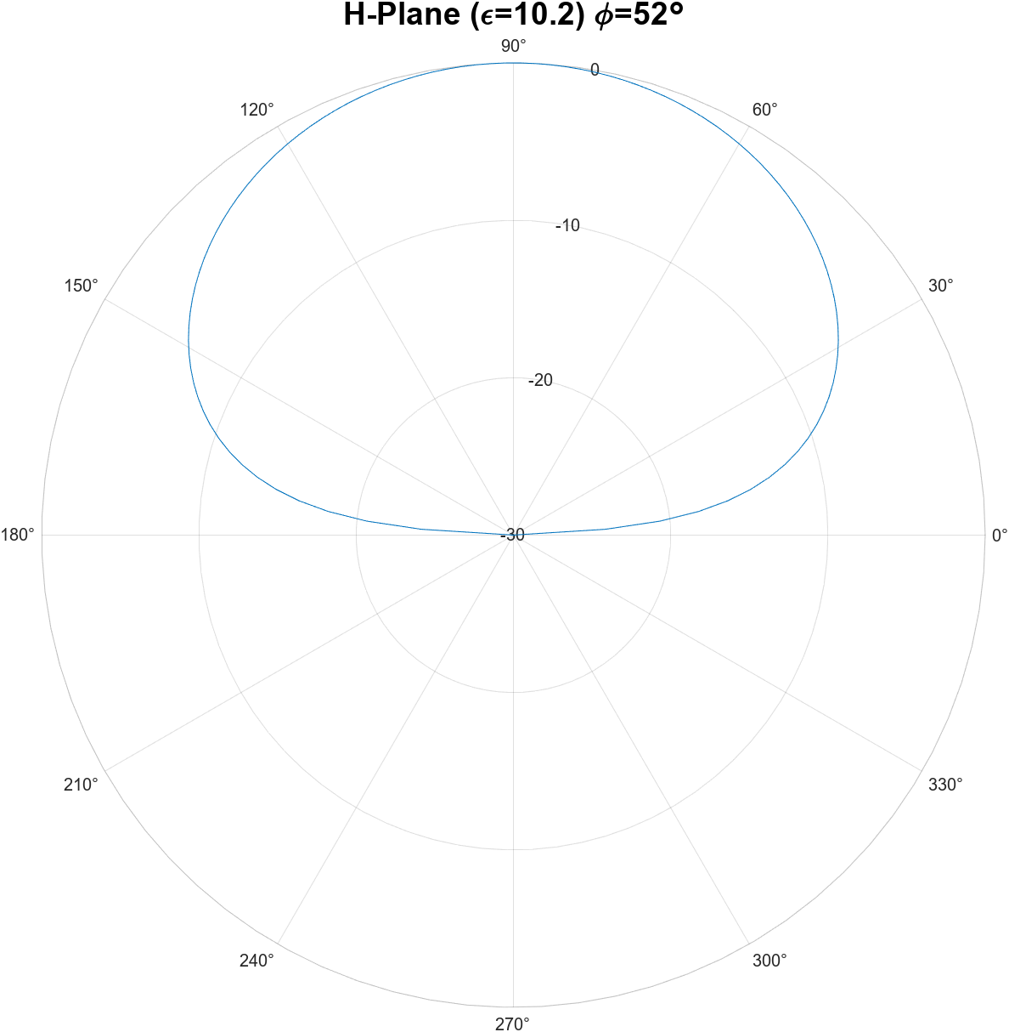

Directivity = 1.8 dBi

* 1. Calculate and plot the E, H, and phi=52 degree patterns by considering the magnetic currents on the faces x=0, x=a (linear polar). Compare with the co-pol. Pattern in (3). Make sure they are scaled to the same constant so that you can compare their relative magnitude. What is the cross-pol. Level in dB for the two cases?

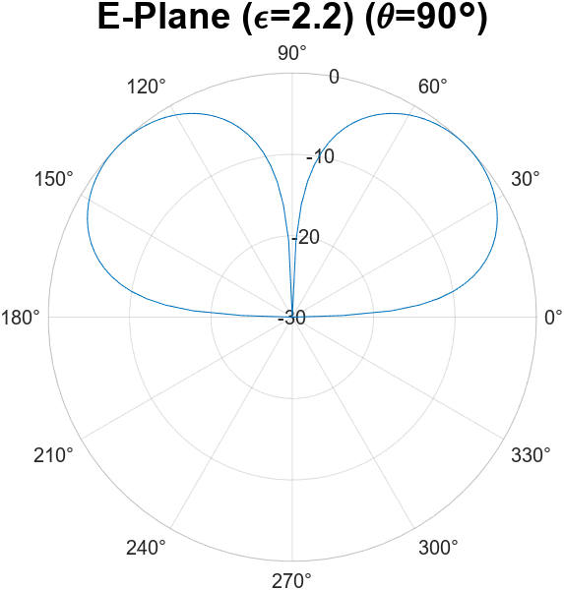

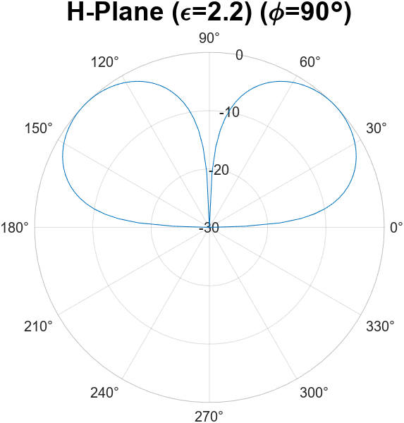

Directivity = 6.98 dBi

* The plots in part D are the cross pols for part C, unfortunately I ran out of time so I couldn’t plot them together. I would normalize the plots of part D with the plots of part C magnitude to determine the cross-pol level. From there I would determine the dBi level of the cross pol.

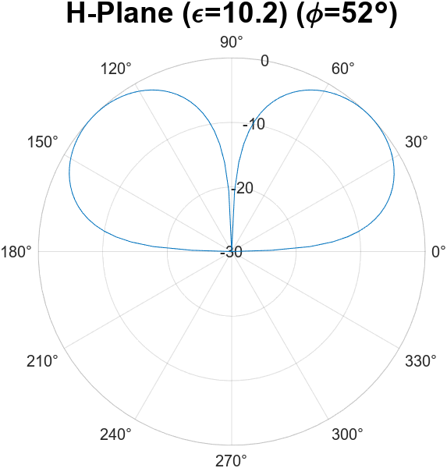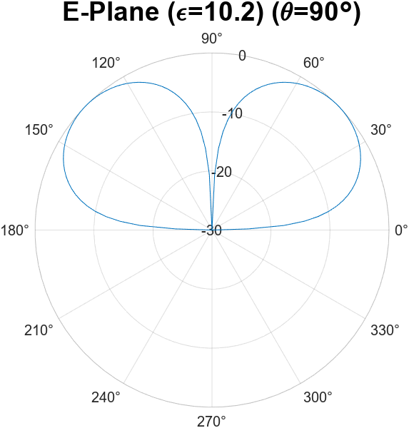

1. For a horn antenna with TE20 mode on the x-axis with a=8λ (x-axis) and b=5λ (y-axis):
   1. Calculate the far field pattern. Plot the E and H plane patterns together on a rectangular, -30dB-0dB range, for 0<θ<90o.
   2. Find the peak radiation angle. Calculate the directivity and aperture efficiency at the peak radiation angle.

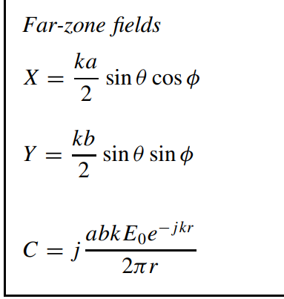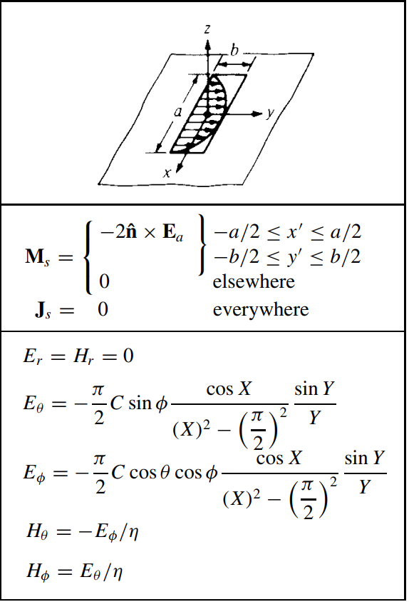

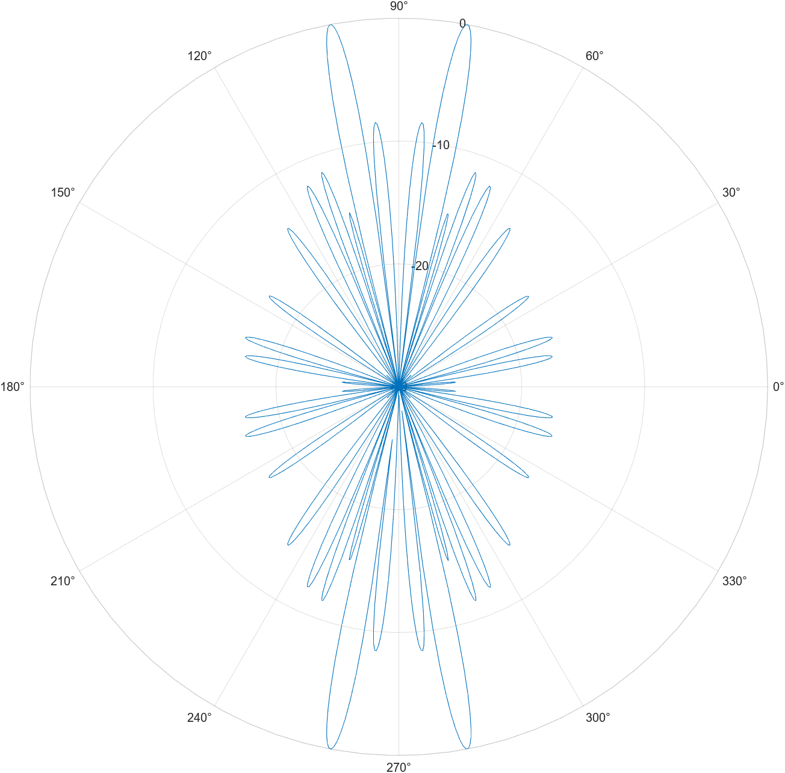

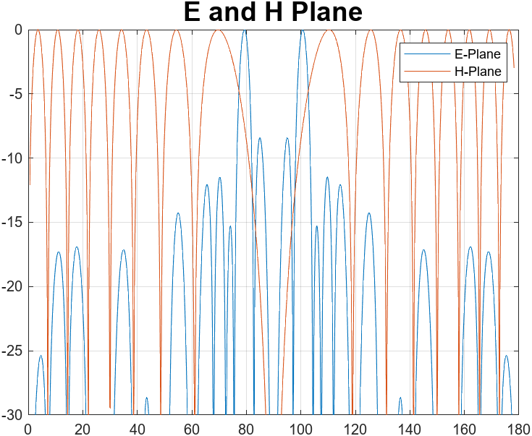

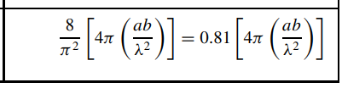

The peak radiation angle are the peaks in E and H plane plot. 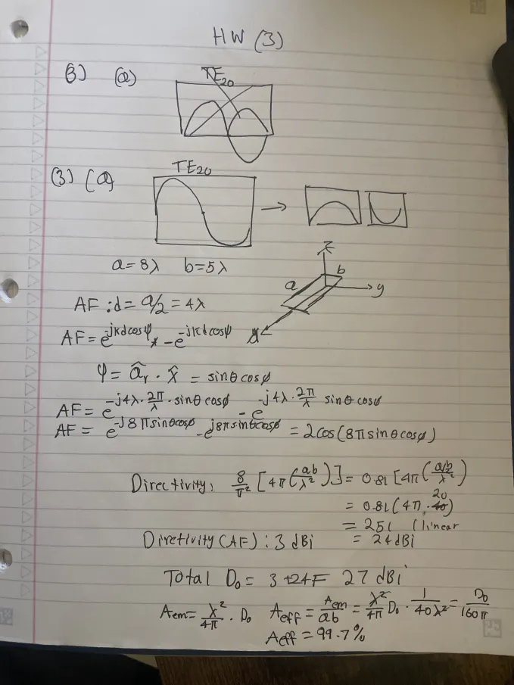

clear all

close all

clc

syms theta phi lambda

a=5*lambda;

b=8*lambda;

k=(2*pi)/lambda;

X(theta, phi) = (k*a/2) * sin(theta) * cos(phi);

Y(theta, phi) = (k*b/2) * sin(theta) * sin(phi);

%C = 1j * a * b * k / (2*pi);

E_theta(theta, phi) = sin(pi/2) * ...

( cos( X(theta, phi) ) / ( (X(theta, phi)) ^ 2 - (pi/2)^2 ) ) * ...

( sin(Y(theta, phi)) / Y(theta, phi) );

E_phi(theta, phi) = cos(theta) * cos(phi) * ...

( cos(X(theta, phi)) / ( (X(theta, phi))^2 - (pi/2)^2 ) ) * ...

( sin(Y(theta, phi)) / Y(theta, phi) );

AF(theta, phi) = 2j*sin(8*pi*sin(theta)*cos(phi));

E(theta, phi) = sqrt( abs(E_theta(theta, phi))^2 + abs(E_phi(theta, phi))^2 ) * AF(theta, phi);

E1 = matlabFunction(E);

% E-Plane

phi1 = linspace(0.01, .99*pi, 1000);

theta1 = zeros(1, length(phi1)) + deg2rad(90);

EPlane = E1(theta1, phi1);

EPlane = abs(EPlane) ./ max(abs(EPlane));

EPlane = abs(EPlane) .^ 2;

EPlane = 10 .* log10(EPlane);

EPlane(EPlane < -31) = -31;

plot(rad2deg(phi1), EPlane, "DisplayName", "E-Plane");

ylim([-30, 0]);

hold on;

% H-Plane

theta1 = linspace(0.01, .99*pi, 1000);

phi1 = zeros(1, length(theta1)) + deg2rad(90);

HPlane = E1(theta1, phi1);

HPlane = abs(HPlane) ./ max(abs(HPlane));

HPlane = abs(HPlane) .^ 2;

HPlane = 10 .* log10(HPlane);

HPlane(HPlane < -31) = -31;

plot(rad2deg(theta1), HPlane, "DisplayName", "H-Plane");

ylim([-30, 0]);

grid on

title("E and H Plane", "FontSize", 18);

legend();

D0 = 10 * log10(compute_directivity(AF));

function [theta_max, phi_max, U_max] = findUmax(U_func)

if nargin(U_func) == 2

% Define a nested function to be minimized

neg_U_func = @(x) -U_func(x(1), x(2));

% Initial guess for theta and phi

x0 = [0, 0];

% Perform the optimization

[x_max, U_max] = fminsearch(neg_U_func, x0);

% Extract theta_max and phi_max

theta_max = x_max(1);

phi_max = x_max(2);

U_max = -U_max;

elseif nargin(U_func) == 1

% Define a nested function to be minimized

neg_U_func = @(x) -U_func(x(1));

% Perform the optimization

options = optimset('Display','iter');

% Bug in MATLAB

xValue = fminbnd(neg_U_func, -pi, pi, options);

% Extract theta_max and phi_max

theta_max = xValue;

U_max = U_func(xValue);

phi_max = 0;

else

error('Incorrect number of input arguments.');

end

end

function D0 = compute_directivity(field)

if nargin(matlabFunction(field)) == 2

syms theta phi

U_inten = matlabFunction(abs(field) .^ 2);

Prad = matlabFunction(U_inten(theta, phi) * sin(theta), 'Vars', {theta, phi});

Prad_value = integral2(Prad, 0, pi, 0, 2*pi);

[~, ~, Umax] = findUmax(U_inten);

D0 = (4*pi*Umax)/Prad_value;

elseif nargin(matlabFunction(field)) == 1

syms theta

U_inten = matlabFunction(abs(field) .^ 2);

Prad = matlabFunction(U_inten(theta) * sin(theta), 'Vars', {theta});

Prad_value = 2*pi*integral(Prad, 0, pi);

[~, ~, Umax] = findUmax(U_inten);

D0 = (4*pi*Umax)/Prad_value;

else

error('Incorrect number of input arguments.');

end

end

1. Take a rectangular aperture with |x|<a/2 and |y|<b/2, (a=6λ and b=8λ). surrounded by an infinite ground-plane. The electric field across the aperture is given by

for

* 1. Calculate the E and H plane patterns. Plot the E-plane in phase, quadrature and total patterns for $α{(a/2)}^{2}=π/4$, on a rectangular, -30dB-0dB range, for 0<θ<90o. (hint: calculate f(kx, ky) first)
  2. Calculate the aperture efficiency. Use the coupling formula.



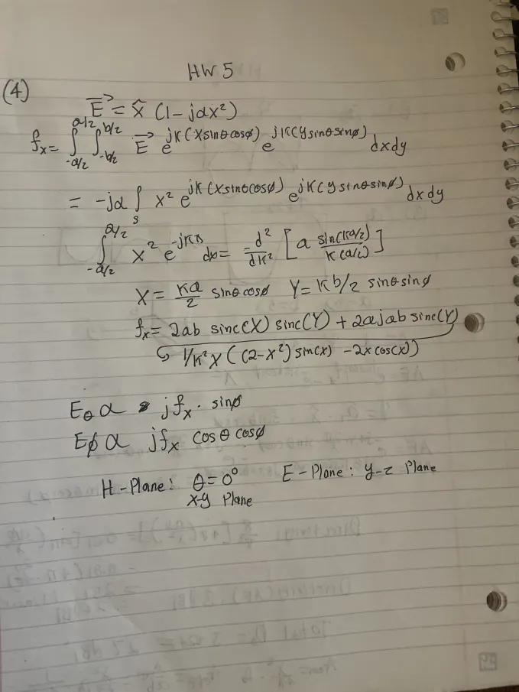

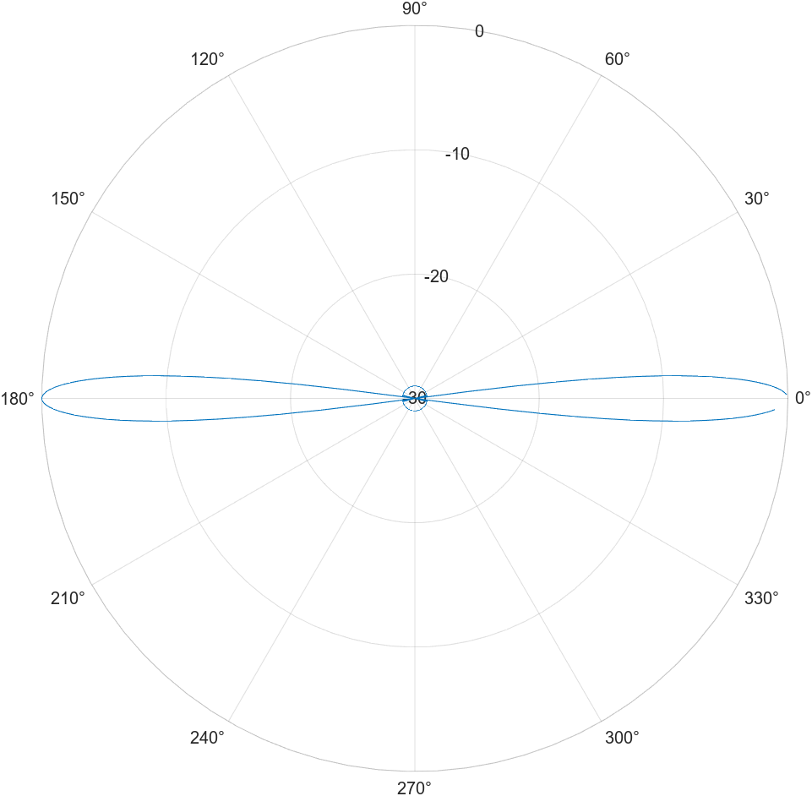

1. Design a 23-dBi standard gain horn antenna for 18-26 GHz operations (K band). The feeding waveguide is WR42 (find the waveguide dimensions on internet). The gain is specified at 22 GHz. Plot the gain and aperture efficiency at 14-32 GHz. What is the phase error across the x and y direction at 18 and 26 GHz, respectively? To what maximum frequency you would like to use this horn, What is the limiting factor?

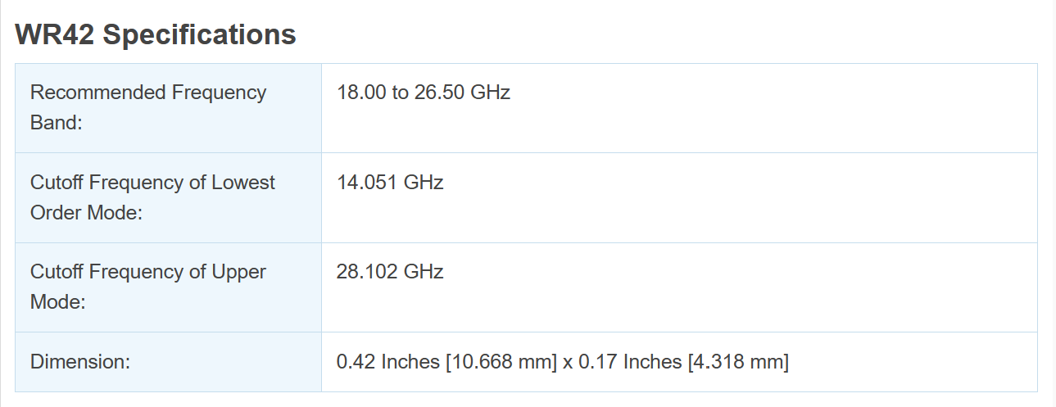

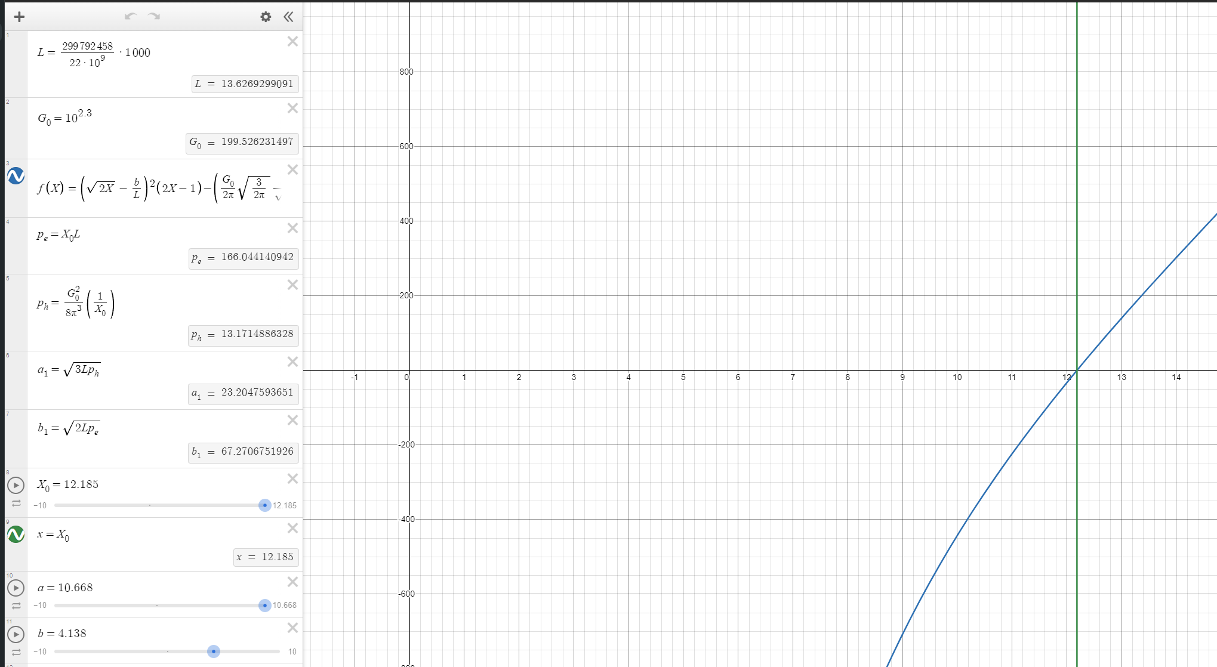

(Design Graph)

[HornAntenna | Desmos](https://www.desmos.com/calculator/bmzgxqf7db)

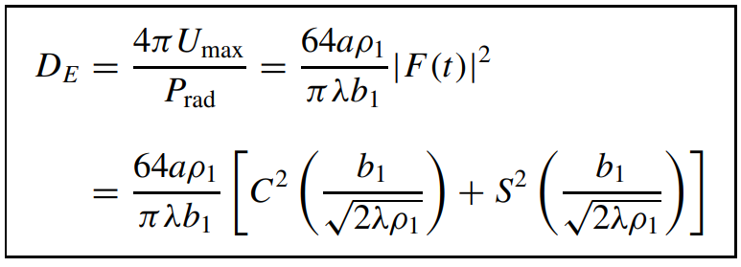

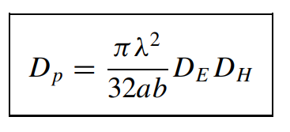

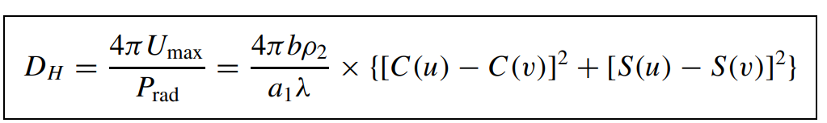

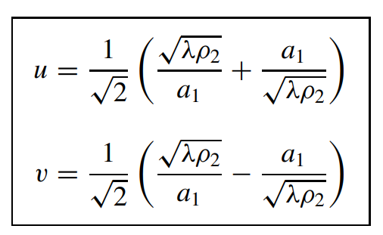

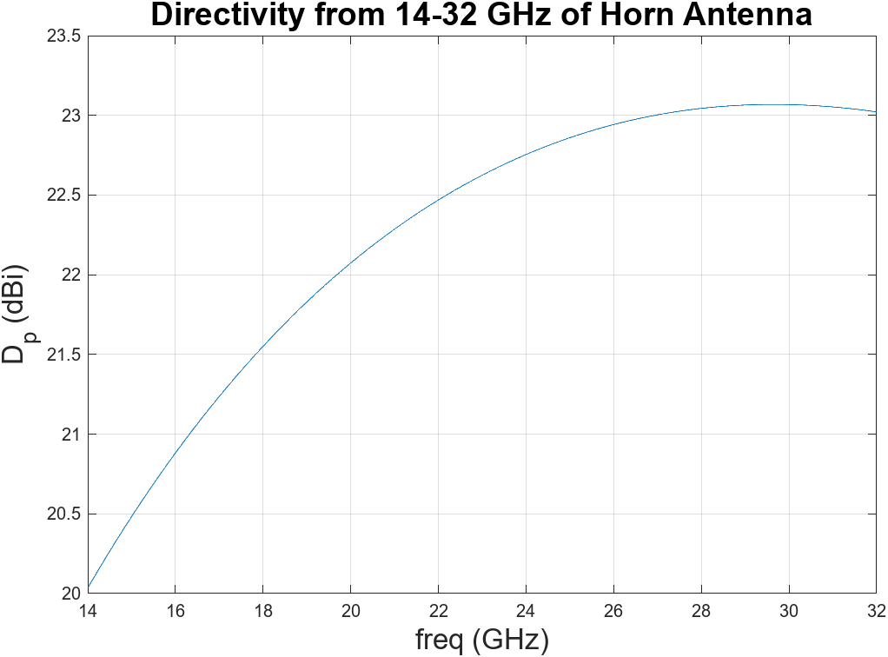

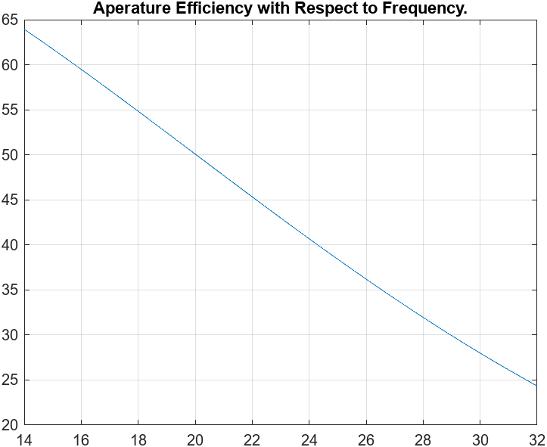

clear all

close all

clc

syms x f lambda X

% Dimenions are in mm

a = 10.668*1e-3;

b = 4.138*1e-3;

f0 = 22e9;

G0_dbi = 23;

G0 = 10^(G0_dbi/10);

Lambda(f) = (3e8/f);% * 1e3; % lambda in mm from frequency in Hz

a1 = 85.66*1e-3;%23.20;

b1 = 67.27*1e-3;%67.27;

pe = 152.599655472*1e-3;

ph = 152.599655472*1e-3;%13.17;

C(x) = fresnelc(x);

S(x) = fresnels(x);

DE(lambda) = ((64*a*pe)/(pi*lambda*b1)) * ( (C(b1/sqrt(2*lambda*pe)))^2 + (S(b1/sqrt(2*lambda*pe)))^2 );

u(lambda) = (1/sqrt(2)) * ( sqrt(lambda*ph)/a1 + a1/sqrt(lambda*ph) );

v(lambda) = (1/sqrt(2)) * ( sqrt(lambda*ph)/a1 - a1/sqrt(lambda*ph) );

DH(lambda) = (4*pi*b*ph)/(a1*lambda) * ( (C(u(lambda)) - C(v(lambda)))^2 + (S(u(lambda)) - S(v(lambda)))^2 );

DP(lambda) = (pi*lambda^2)/(32*a*b) * DE(lambda) * DH(lambda);

DP(lambda) = matlabFunction(DP);

f1 = linspace(14e9, 32e9, 1000);

lam1 = eval(Lambda(f1));

Dp1 = eval(DP(lam1));

plot(f1/1e9, 10.0.*log10(Dp1));

xlabel("freq (GHz)", "FontSize", 16);

ylabel("D_{p} (dBi)", "FontSize", 16);

title("Directivity from 14-32 GHz of Horn Antenna", "FontSize", 18);

grid on;

%% Aperature Efficieincy

figure

Aem = lam1 .^ 2 ./ (4 * pi) .* Dp1;

ApertureEff = Aem ./ (a1 * b1);

plot(f1/1e9, ApertureEff*100)

grid on;

title("Aperature Efficiency with Respect to Frequency.");

